TRAINING AND PLACEMENT CELL
ACADEMIC YEAR 2024-2025
HEGURU PLACEMENT DRIVE ON 12.05.2025
We are delighted to share that Achariya Arts and Science College successfully organized a Placement Drive in collaboration with Heguru, Chennai , on Monday, 12th May 2025.
‎‎A total of 57 enthusiastic final-year UG students participated in the drive, applying for the positions of Assistant Trainer and Admission Counsellor, with an annual CTC ranging from Rs. 2.25 to 2.70 Lakhs. We feel delighted and proud to announce that 09 students have been selected and received offer letters.
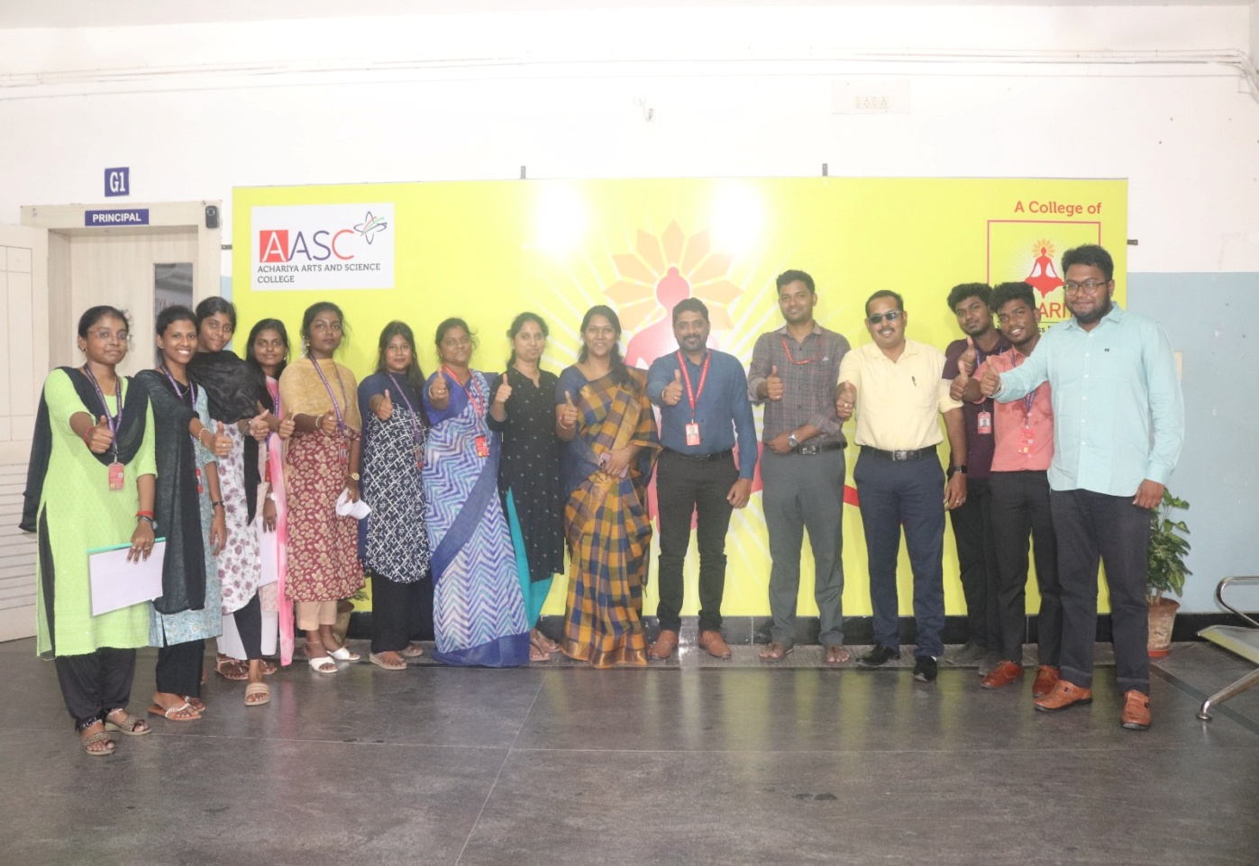
‎‎This placement drive served as a valuable platform for our students to demonstrate their capabilities and secure promising career opportunities. We sincerely thank Heguru, Chennai for their support and looking forward to their continued collaboration in our future ventures.
‎

